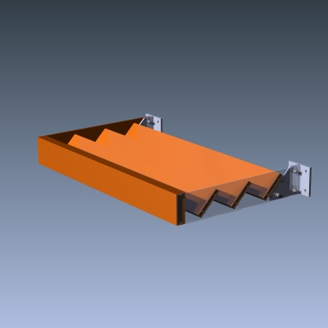
ST Series Sunshade

STANDARD CONSTRUCTION
- Material: Extruded Aluminum 6063-T6 and/or 6061-T6
- Fascia: Round Tube, .125” (3.2mm) nominal wall thickness
- Blades: Rectangular / Round Tubes (various sizes) , minimum .081” (2.1mm) nominal wall thickness
- Outriggers: Flat Bar, .25” (6.4mm) or .375” (9.5mm) nominal wall thickness
- Mounting Brackets: Extruded Aluminum Tee
- Finish: Mill

OPTIONAL ACCESSORIES
- Aluminum suspension rods
- Segmented or radius formed components
- All sizes are custom fabricated to meet project requirements
- Tube or Channel Outriggers

Finishes
- 2 coat fluropolymer: Kynar® 500 / Hylar® 5000 custom colors available in 70% PVDF
(AAMA 2605) or 50% PVDF (AAMA 2604) formulas.
- 3 coat fluropolymer: Kynar 500 / Hylar 5000 custom colors available in 70% PVDF
(AAMA 2605) formulas.
- Anodic finishes: Class I & Class II in Clear, Light/Medium/Dark Bronze, Champagne & Black.
- Prime coat
- Mill

SUGGESTED SPECIFICATIONS

General: Furnish and install where indicated on drawings ST Series Sunshade as manufactured by Industrial Louvers, Inc., Delano, MN.

Material: Blades to be fabricated from 6063-T6 extruded aluminum rectangular/round tubes, minimum wall thickness .081”. Fascia shall be fabricated from .125” extruded aluminum tubes. Outriggers shall be fabricated from extruded aluminum flat bar, minimum wall thickness of .25”. Suspension rods (as required) shall be 3/4” diameter aluminum rod. Mounting brackets shipped loose.

Sunshades shall be installed in accordance with manufacturer’s recommended attachment method and in accordance with state and federal building codes.

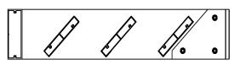
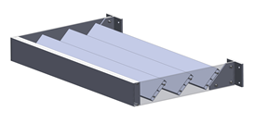
CATALOG NO. ST Series Rev: Feb 2015

Qty. | Size: Actual □ M.O. □ |  | Mullion  Type | No. of Sections | Notes
Qty. | Width | Height | Mullion  Type | No. of Sections | Notes
□ | Sill flashing: |  | Project:
□ | Screen: |  | Location:
□ | Finish: |  | Architect:
□ | Color: |  | Representative:
□ | Other: |  | Date: Job #:

Typical Assembly
Horizontal Section

